King Fahd University of Petroleum & Minerals College of Computer Sciences and Engineering

Information and Computer Science Department

ICS 321

Phase II

Date of submission: 15/12/2022 Team number : 69

|  |  |
| --- | --- |
| **Name** | **ID** |
| ALI ALEID | 201927190 |
| ABDULAZIZ ALSOUHIBANI | 201922670 |
| MSHARI ALKHALIFAH | 201957090 |

Table of Contents

1.EER 3

2.Relational Schema 4

3.Constraints and Business rules 5

4.Tools & Resources 6

5. implementation details 6

6. Problems we faced 6

7. Lessons learned from the project 7

8. Percentage Completion of each required operation 7

9. Tasks assignment 7

10. Suggestions to improve ICS321 future projects 8

# 1.EER

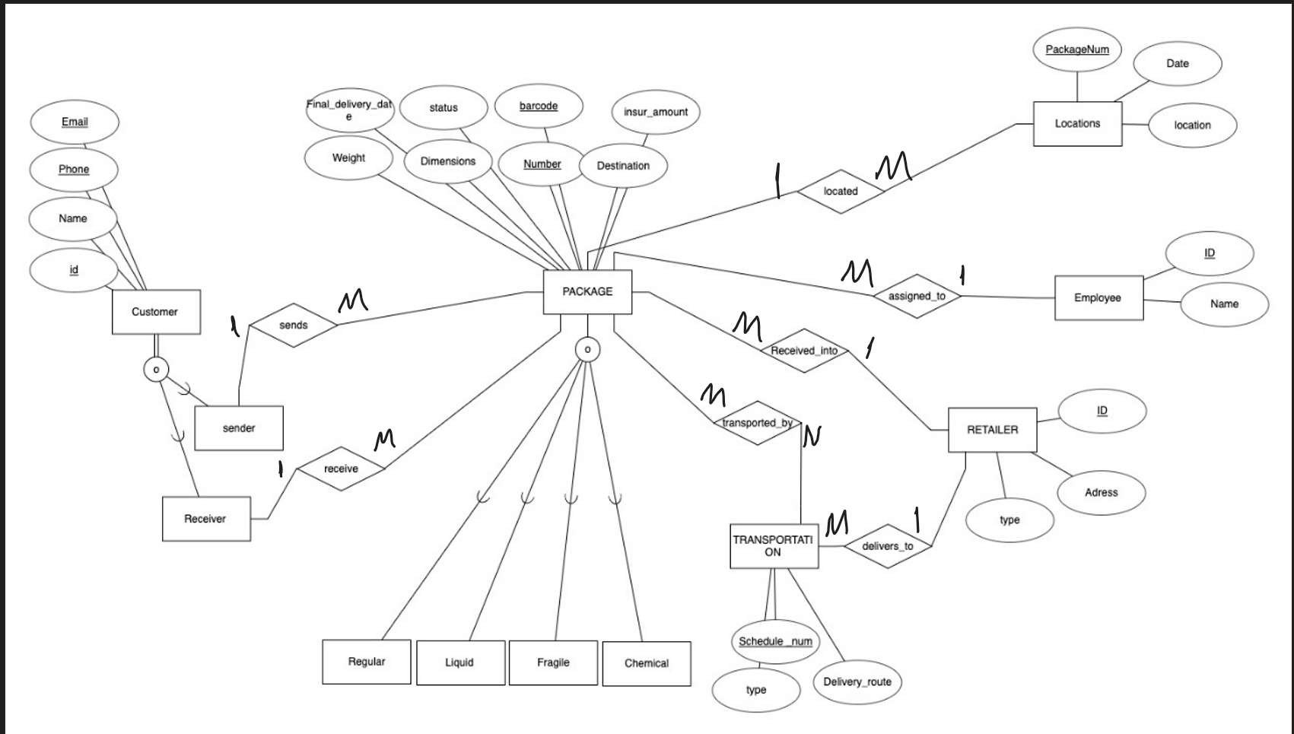

# 2.Relational Schema

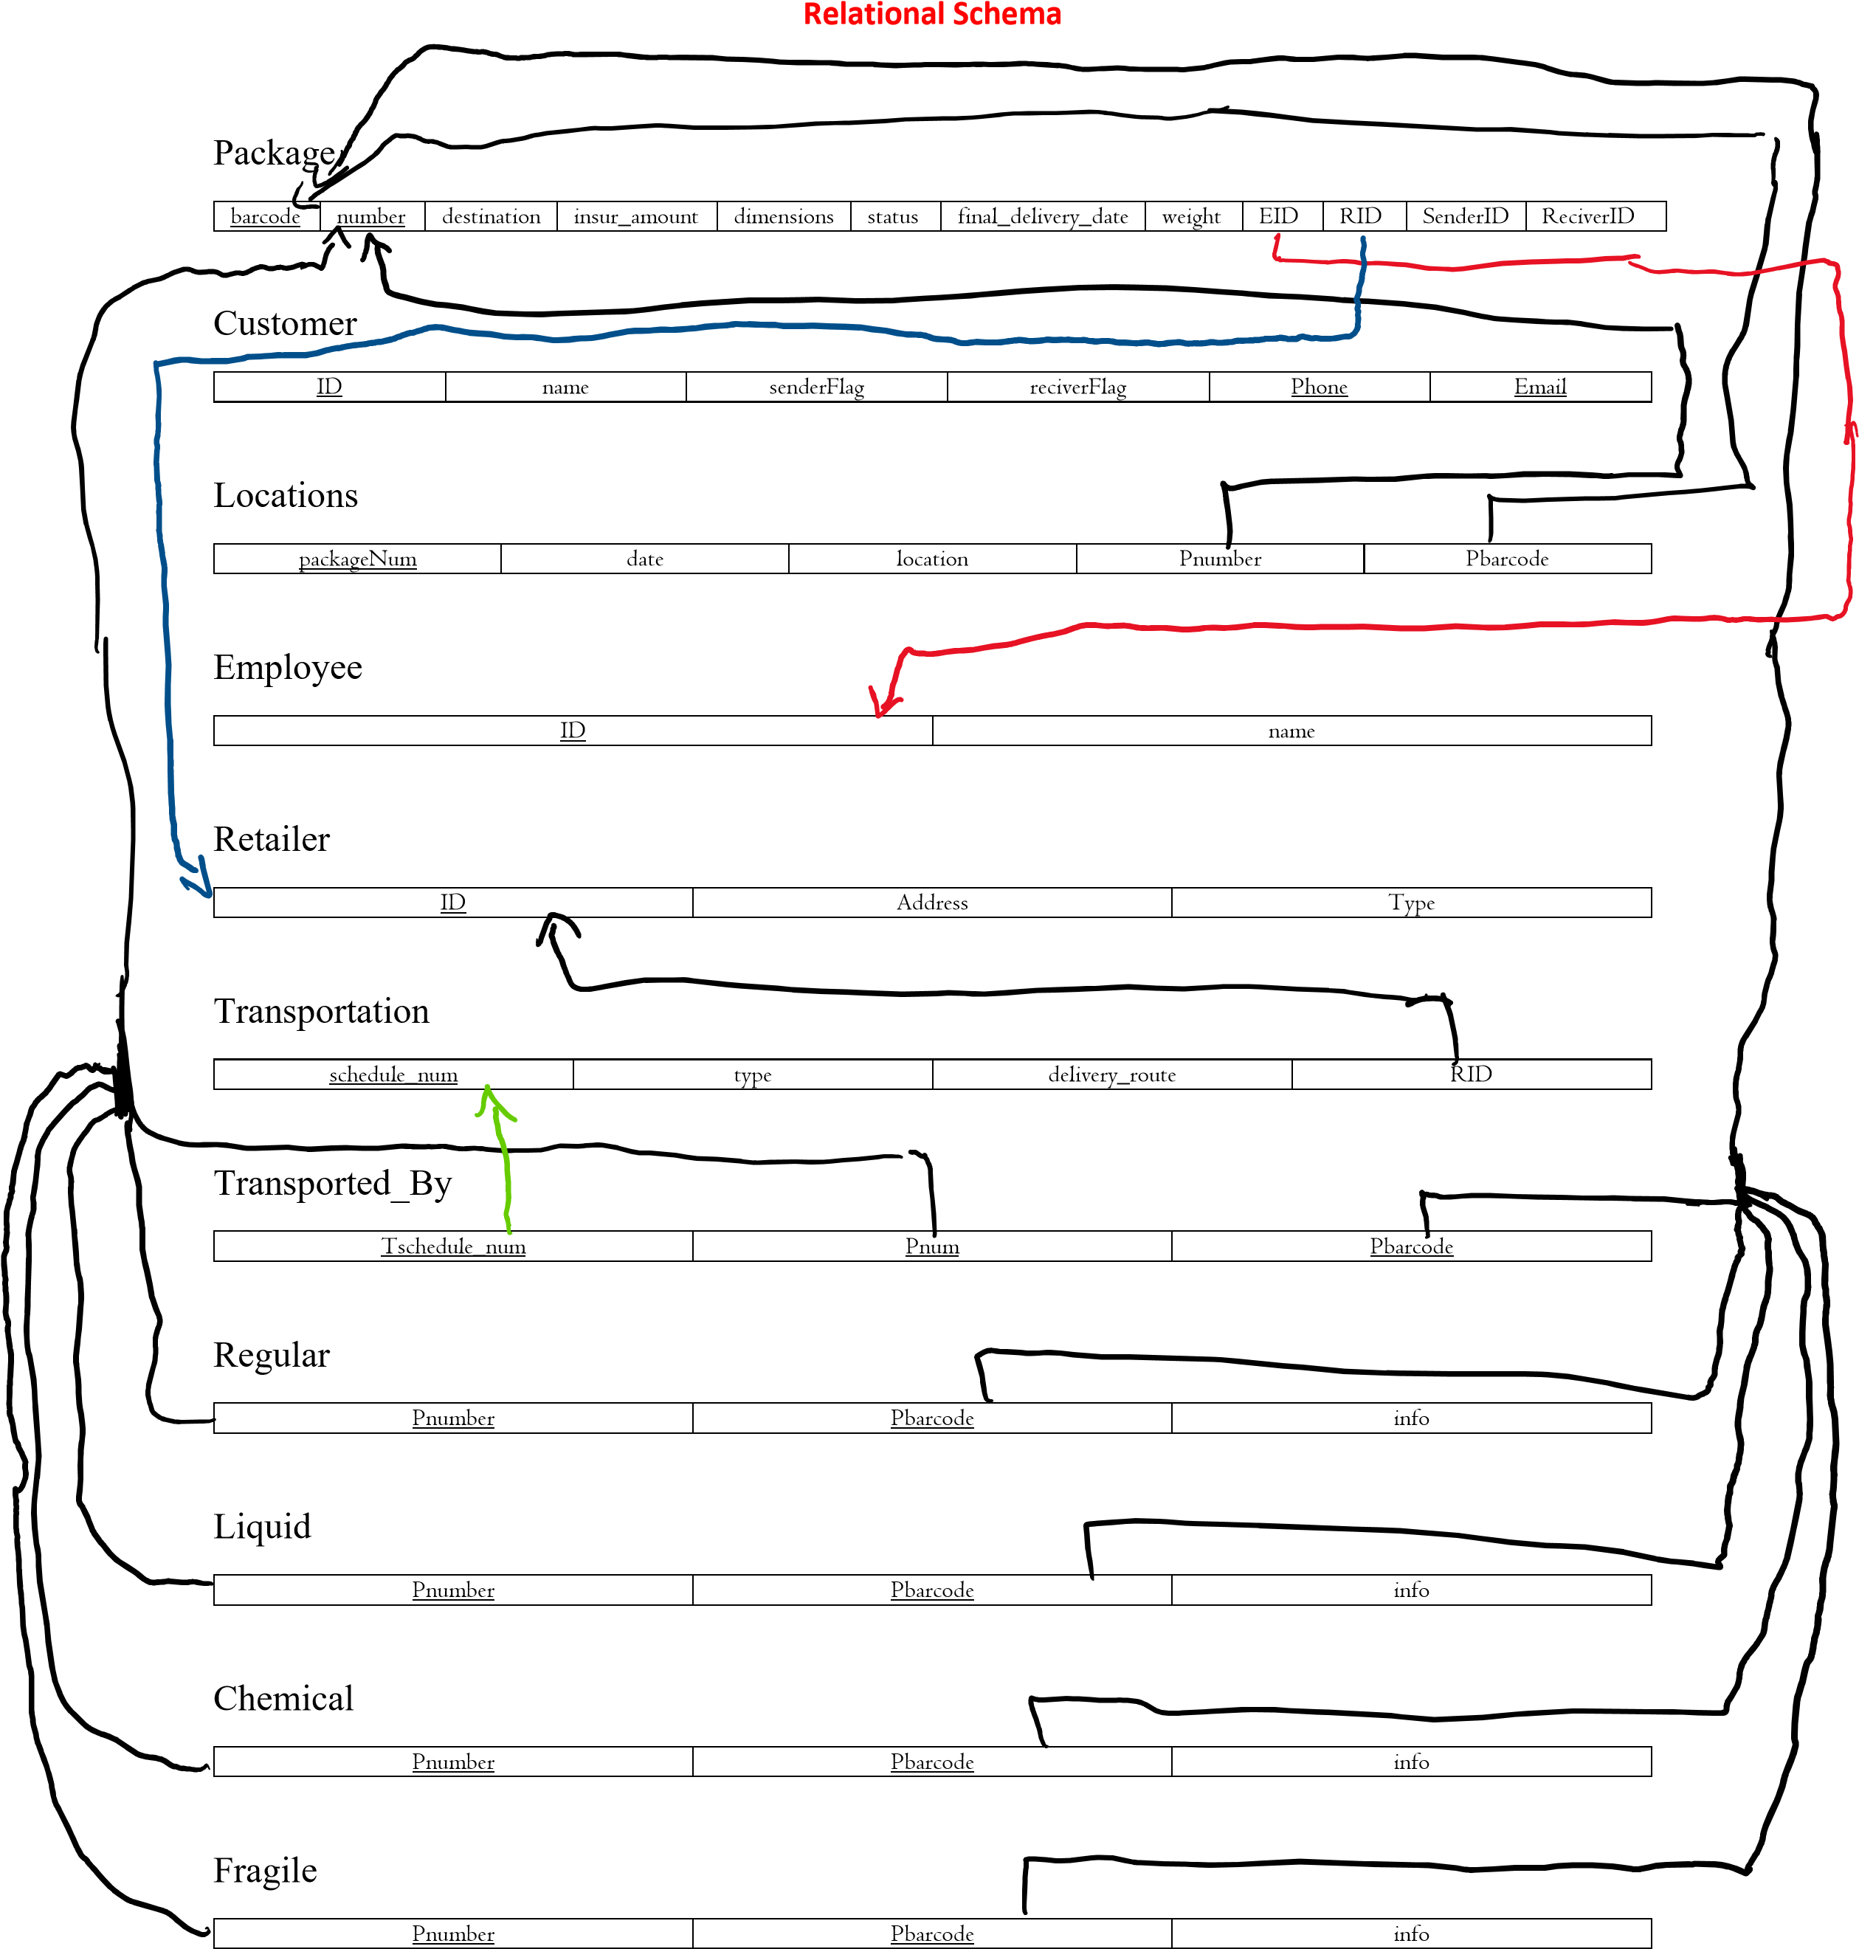

# 3.Constraints and Business rules

1. The packages are categorized as Regular, Fragile, Liquid, Chemical etc.
2. The status of the packages is as follows in transit, delivered, lost or damaged.
3. The value and insurance amount of the package is maintained as well as the payment to the company based on weight as cost for delivering the package.
4. Any company employee or customer should be able to search their packages by their ID, category, city and delivery date.
5. The movement history including the current place of the package in transit must be produced upon request.
6. The system should be able to retrieve information of packages not delivered, damaged or

lost.

1. The system should identify fines for delayed packages. For lost or damaged packages, the insurance amount is delivered to the customer instead of the package.
2. The system should be able to send notifications whenever the packages become available for delivery as well as if they are delayed.
3. Each package will have a unique barcode that the system will be able to read.

# 4.Tools & Resources

* <https://erdplus.com/> to draw the EER diagram
* expressJS, nodeJS, for server side scripting
* nunjucks for html templates
* Bootstrap for frontend
* Sqlite3 for the database

# 5. implementation details

We created view folder that contains the html pages, and model folder contains a js file that has the necessary queries, and finally a js file called server.js that acts as an api between the frontend and the database.

# 6. Problems we faced

* Requirements given weren’t clear
* Should we create a table for delayed package or not?
* Should we cascade the deletion? and How?
* Verification of users

# 7. Lessons learned from the project

* Work as a team
* Good communication improves productivity
* Using Agile approach of this project, helped in fast delivery with required quality
* Asking help from experts (e.g. Professors) can reduce the work time

# 8. Percentage Completion of each required operation

|  |  |
| --- | --- |
| Task | % Completion |
| Designing UI | 100% |
| Creating the database | 100% |
| Filling the database with some values | 100% |
| Writing the necessary queries | 100% |
| Authorization | 70% |
| Connecting the backend with frontend | 70% |

# 9. Tasks assignment

We distributed the work based on the knowledge areas, since ABDULAZIZ & MSHARI are taking a web engineering course, they are mainly responsible for the backend and the API.

ALI was responsible for desiging the User Interface and making sure that it is easy to use, along with creating the database and writing the needed queries from the frontend.

|  |  |
| --- | --- |
| Name | tasks |
| ALI ALEID | UI & Queries from frontend |
| ABDULAZIZ ALSOUHIBANI | Authorization & backend |
| MSHARI ALKHALIFAH | backend |

# 10. Suggestions to improve ICS321 future projects

* Improving the organization of the projects (e.g. releasing the project in the early weeks)
* Providing an email in the document for any related questions
* Providing the grading criteria
* Writing clearer requirements
* Demonstrating the project in class
* Dividing the project on multiple phases (e.g. ph1:EER, ph2: UI design, ph3: implementation), and submitting the phases early in the semester leaving the implementation phase to be at the end.